Newtownhamilton Primary School Uniform
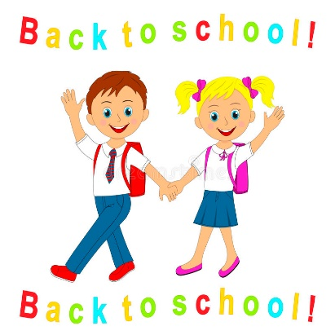

Uniform can be purchased from Lila’s, Scotch Street, Armagh

Our school uniform is as follows-
Girls –
Royal blue sweatshirt with school logo
White polo shirt (also available with school logo)
White socks or grey tights
Grey skirt
Reception Pupils only
Reception pupils are permitted to wear the P.E navy track bottoms with velcro trainers everyday as this will make toileting easier to manage.

Black school shoes (not trainers)

Boys –
Royal blue sweatshirts with school logo
White polo shirt (also available with school logo)
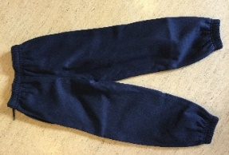
Grey trousers
Black school shoes (not trainers)

Our PE Uniform is as follows-
All pupils-
White t-shirt (Rec-P3 school polo shirt/ P4-P7 white PE t-shirt with logo which is available to purchase in Lila’s in Armagh)
Navy shorts (Plain navy tracksuit bottoms or leggings can be worn on cooler days)
White socks
Trainers

**It is essential for ALL pupils to have proper gym shoes/trainers to take part in P.E. in the school gymnasium.

**All children may come to school dressed for PE on designated days (currently Friday).

**Pupils will not be allowed to do P.E. if they are improperly dressed, and this includes the wearing of any kind of jewellery. The wearing of football shirts and replica kits etc is not permitted for PE lessons.

School P.E. kit is compulsory for all children from P4 upwards.

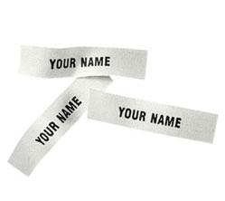
School coats may be ordered from the school at the beginning of each school year. Order Forms will be distributed to parents at the appropriate time. Please note that the purchase of the coat is not compulsory.
It is ESSENTIAL that all items of clothing including coats, shoes, school bags, P.E. bags and lunch boxes etc are clearly marked with your child’s name. This makes finding misplaced jumpers and other items much simpler for staff.

